DMV ASSIGNMENT 2

Syed Muhammad Hassan Raza – 26645

1. Display all the order related information for the orders in 2013 and above

SELECT * FROM DBO.OEHR_ORDERS

WHERE

YEAR (CAST(SUBSTRING(ORDER_DATE,1,9)AS DATE)) >= 2013

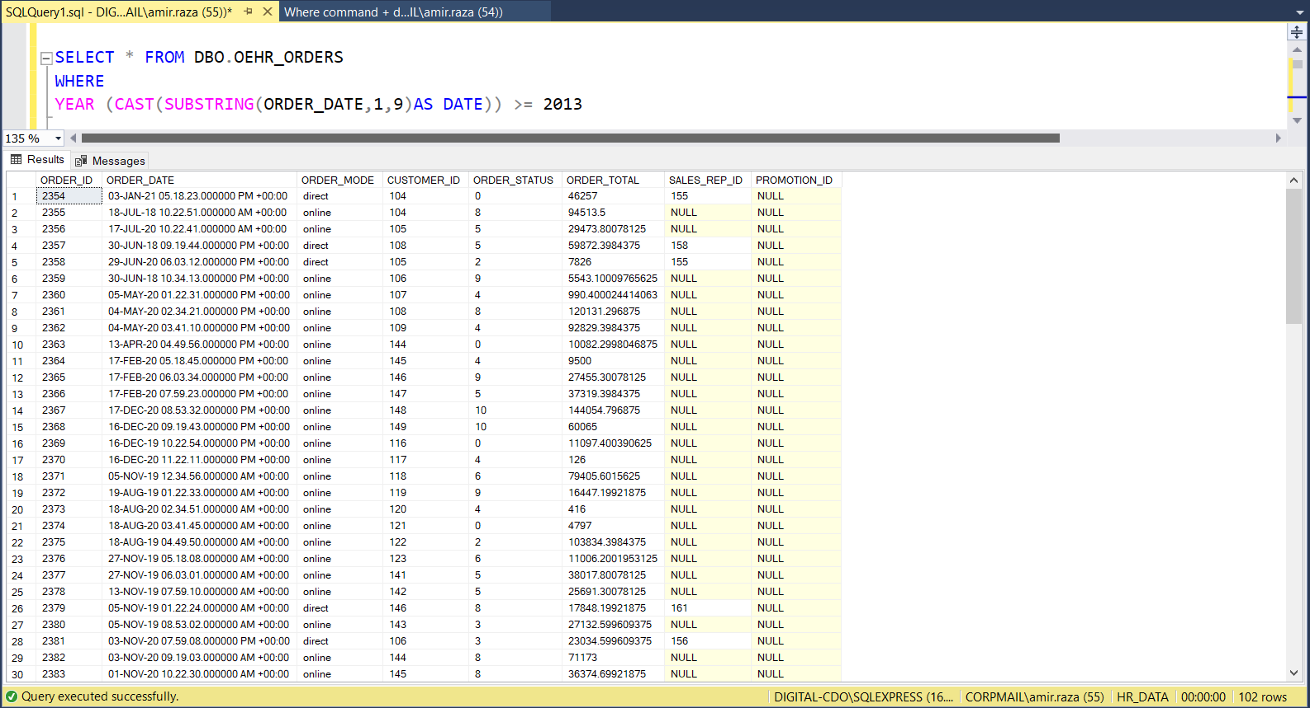

2. Display the job history of all the employees from 2010 to 2015.

SELECT *

FROM DBO.OEHR_JOB_HISTORY A JOIN DBO.OEHR_EMPLOYEES B

ON A.EMPLOYEE_ID = B.EMPLOYEE_ID

WHERE YEAR(A.START_DATE) BETWEEN 2010 AND 2015

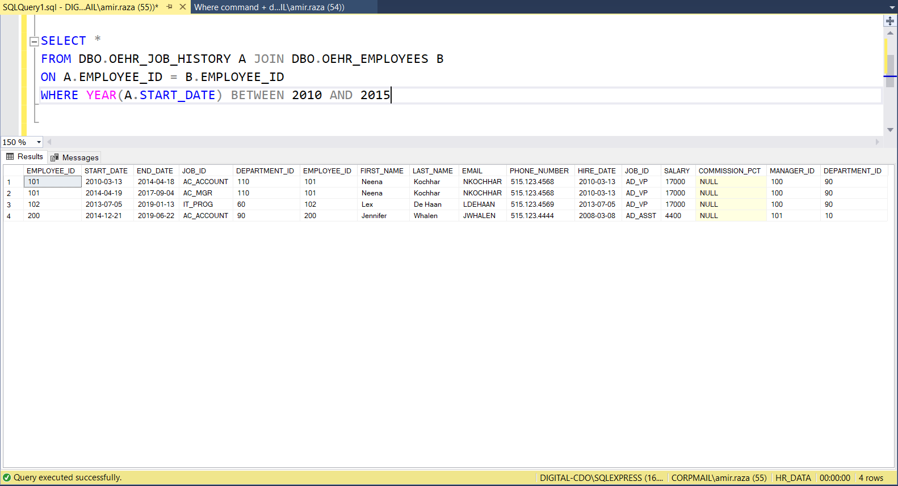

3. Show the breakdown of the number of orders by order mode and order status.

SELECT ORDER_MODE, ORDER_STATUS, COUNT(*) AS 'Number Of Orders'

FROM DBO.OEHR_ORDERS

GROUP BY ORDER_MODE, ORDER_STATUS

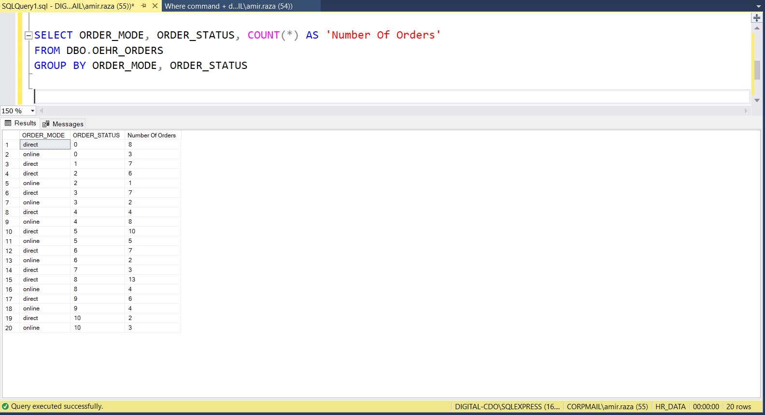

4. Shown by department id, tell me how many employees each department has, the total salary each department takes, and the average salary each department takes.

SELECT DEPARTMENT_ID, COUNT(*) AS 'NUMBER OF EMPLOYEES', SUM (SALARY) AS 'TOTAL SALARY', AVG (SALARY) AS 'AVERAGE SALARY'

FROM DBO.OEHR_EMPLOYEES

GROUP BY DEPARTMENT_ID

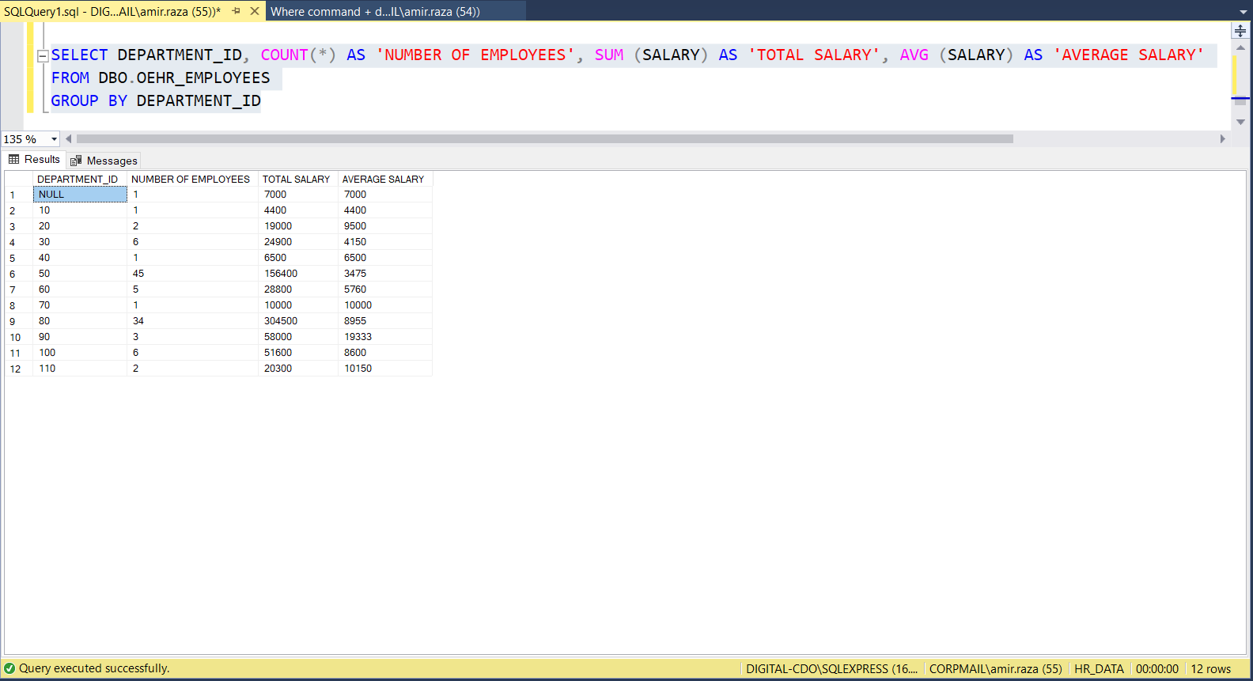

5. Show me the total number of customers, and total distinct number of customers in each country id.

SELECT COUNTRY_ID, COUNT (*) 'TOTAL NUMBER OF CUSTOMERS', COUNT (DISTINCT (CUSTOMER_ID)) 'DISTINCT CUSTOMERS'

FROM OEHR_CUSTOMERS

GROUP BY COUNTRY_ID

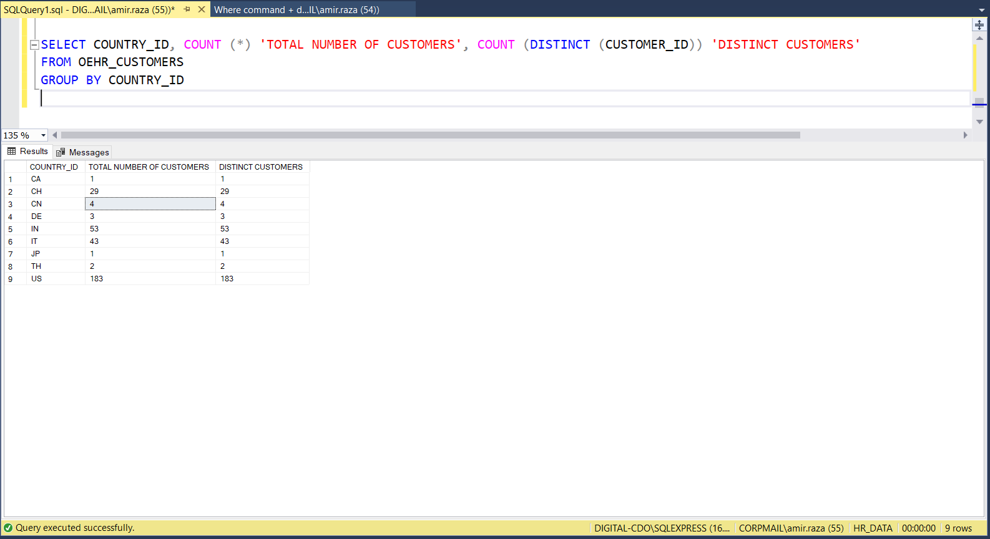

6. Show me the number of customers that live in the city which name starts with 's'.

SELECT COUNT (*) FROM DBO.OEHR_CUSTOMERS

WHERE CITY LIKE 'S%'

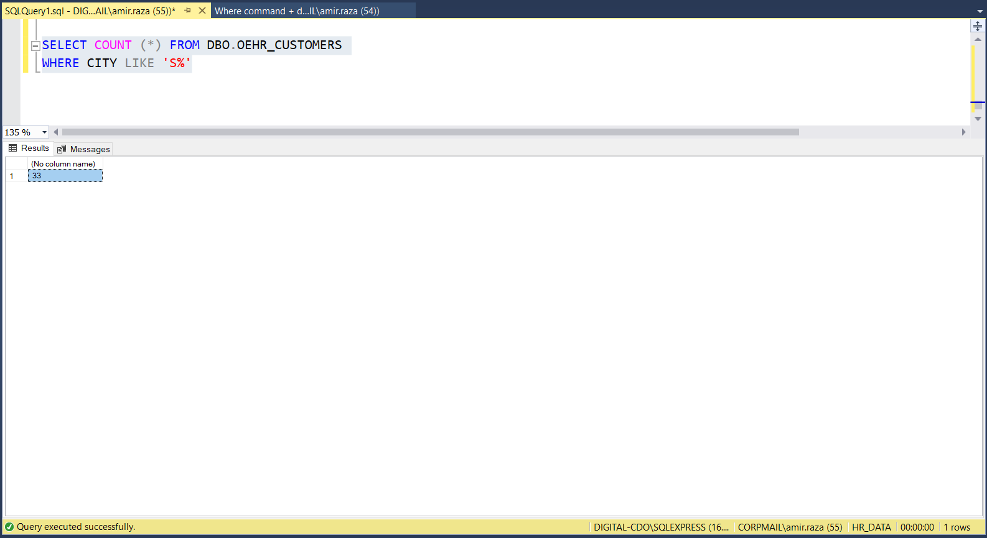

7. Show me the number of customers who have not registered their email on Gmail.

SELECT COUNT (*) AS 'CUSTOMERS NOT REGISTERED ON GMAIL'

FROM DBO.OEHR_CUSTOMERS

WHERE CUST_EMAIL NOT LIKE '%GMAIL%';

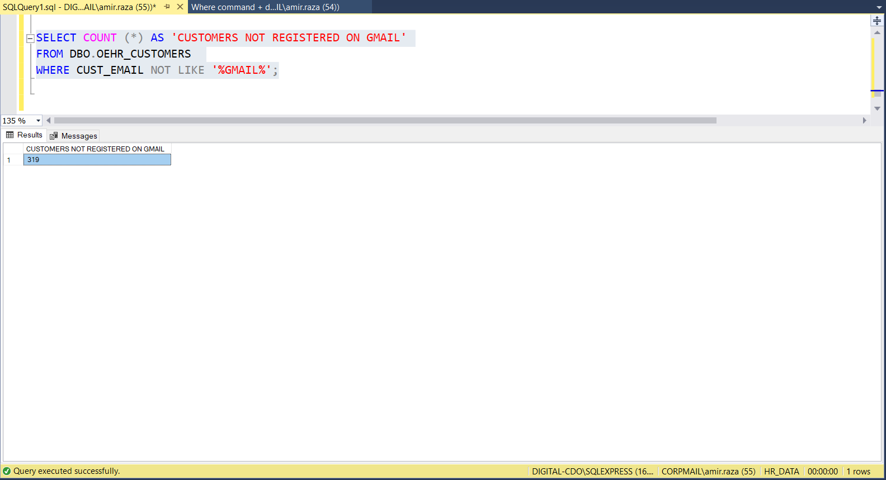

8. Give me the total number of orders by each sales representative (broken up by each sales representative).

SELECT SALES_REP_ID, COUNT (*) AS 'TOTAL NUMBER OF ORDERS'

FROM DBO.OEHR_ORDERS

GROUP BY SALES_REP_ID

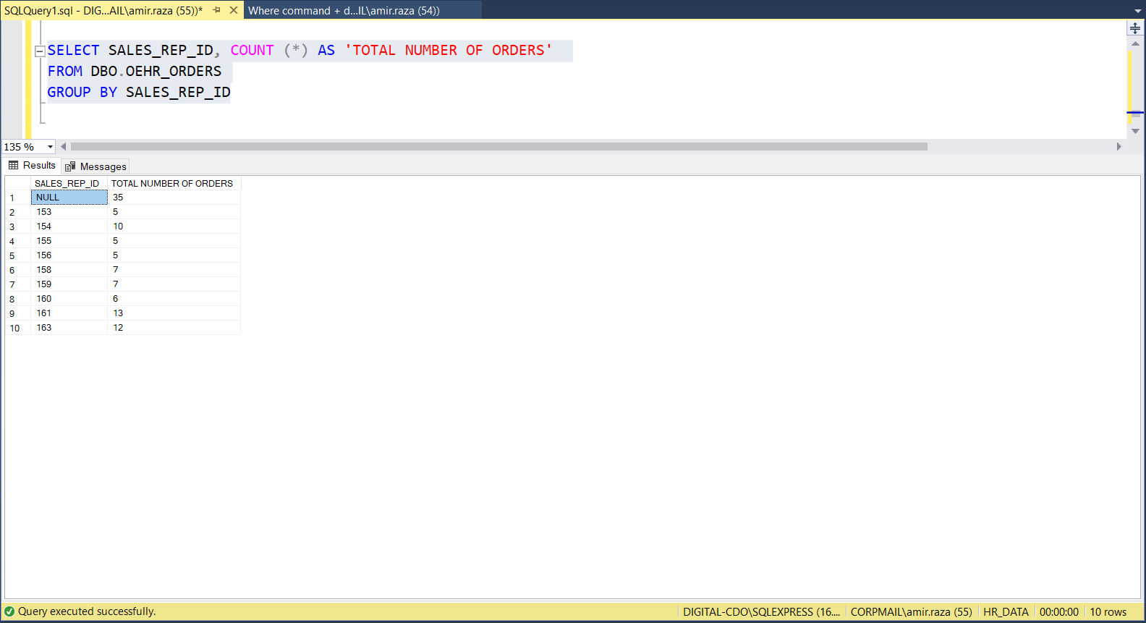

9. Give me the total number of orders in each year.

SELECT YEAR (CAST(SUBSTRING(ORDER_DATE, 1, 9) AS DATE))'ORDER YEAR', COUNT (*) 'NUMBER OF ORDERS'

FROM DBO.OEHR_ORDERS

GROUP BY YEAR(CAST(SUBSTRING(ORDER_DATE, 1, 9) AS DATE))

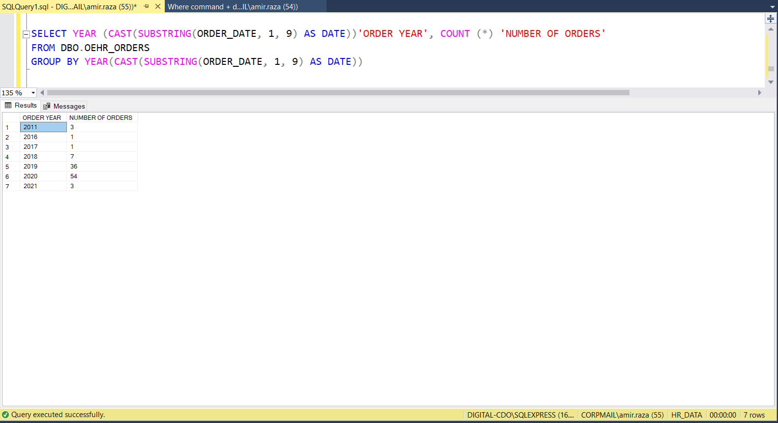

10. Find out the unique postal codes that our customers belong too.

SELECT DISTINCT(POSTAL_CODE)

FROM DBO.OEHR_CUSTOMERS

